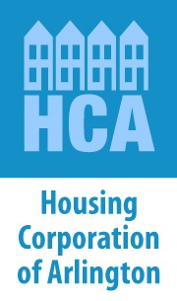
40th Anniversary Stories

HCA’s first acquisition — the 2-family that started it all
by Laura Wiener

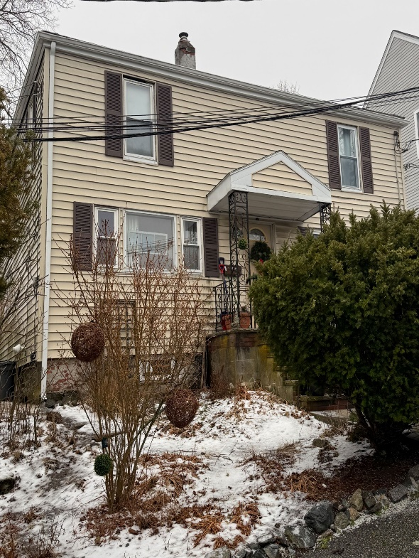
In fall of 2000 I became the first Director of Housing for the Town of Arlington. By that time I had been on the Board of HCA for as long as I lived in Arlington, since 1987.

I was lucky when I started my new job because two very committed public servants had been putting money aside for affordable housing for a couple of years — Alan McClennen, Director of Planning and Community Development (and my new boss) and Select Board member Charlie Lyons. Each year for 3 years they had allocated $100,000 from the federal Community Development Block Grant program for affordable housing, even though they weren’t sure how it would get spent.

I had a little bit of experience working with a non-profit in Watertown that had purchased a 2-family for affordable housing. So I felt like that was the easiest way to get started.

Alan and Charlie, and also Patsy Kraemer, Director of Health and Human Services at the time, and Bob Murray, a former Select Board member all really wanted to get some affordable housing off the ground. HCA was still a young organization at that time — only 4 years old — and had not developed any housing yet, despite real effort. But we all felt that HCA was the logical purchaser, since it was an independent non-profit established by the Town to create affordable housing.

I worked with a broker, looking at 2 families, and most everything was at least $400,000, which was very expensive at the time. Then I saw a property for just under $300,000. It was small, but in good condition. I remember calling Alan on a Saturday and telling him about it, and he said, “Do it”! And I did! That modest 2-family house on Smith Street with the large backyard became the home for 2 single mom households, each with one child. One of those women continues to live there today. It felt so good to jump in and start, and to help two families who were truly in danger of being pushed out of Arlington, if not worse.

That was just the start of HCA eventually buying 15 2-family homes for Arlington families! Over time, HCA transitioned to acquiring or building larger, more financially efficient properties that could help more families as the housing crisis continued to worsen.

As we celebrate our 40th anniversary year, we honor that house on Smith Street, the first in a growing portfolio of protected, restricted, stable affordable homes for Arlington families.

This story was featured in HCA’s January 2026 newsletter

